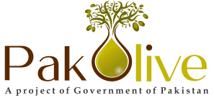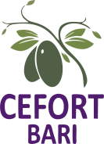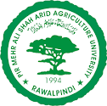

***3rd* INTERNATIONAL OLIVE CONFERENCE**

*on* "Olive Value Chain- A smart Intervention for better future"

*under* PSDP project *"*Promotion of Olive Cultivation on Commercial Scale in Pakistan-Phase-II"

June 7, 2023Wednesday at Auditorium Barani Agricultural Research Institute, Chakwal

**Registration Form**

|  |  |  |
| --- | --- | --- |
|  | **Name** |  |
|  | **Designation** |  |
|  | **Department/Ministry/University** |  |
|  | **Contact Number** |  |
|  | **E-mail ID** |  |
| 6. | **Abstract Submitted** | □ Yes □ No |
| 7. | **Title of the Abstract** | |
|  |  | |
| 8. | **Any other remarks** |  |

**Signature of the participant**

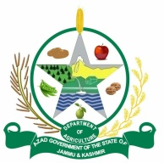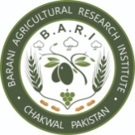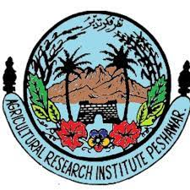Kindly submit dully filled registration form at conference E-mail: 3rdoliveconference@gmail.com